Variables and Data Types in Java

Variable is a name of memory location. There are three types of variables in java: local, instance and static.

There are two types of data types in java: primitive and non-primitive.

Variable

**Variable** is name of *reserved area allocated in memory*. In other words, it is a *name of memory location*. It is a combination of "vary + able" that means its value can be changed.

variables in java

1. **int** data=50;//Here data is variable

### Types of Variable

There are three types of variables in java:

* local variable
* instance variable
* static variable

types of variables in java

#### 1) Local Variable

A variable which is declared inside the method is called local variable.

#### 2) Instance Variable

A variable which is declared inside the class but outside the method, is called instance variable . It is not declared as static.

#### 3) Static variable

A variable that is declared as static is called static variable. It cannot be local.

We will have detailed learning of these variables in next chapters.

### Example to understand the types of variables in java

1. **class** A{
2. **int** data=50;//instance variable
3. **static** **int** m=100;//static variable
4. **void** method(){
5. **int** n=90;//local variable
6. }
7. }//end of class

## Data Types in Java

Data types represent the different values to be stored in the variable. In java, there are two types of data types:

* Primitive data types
* Non-primitive data types

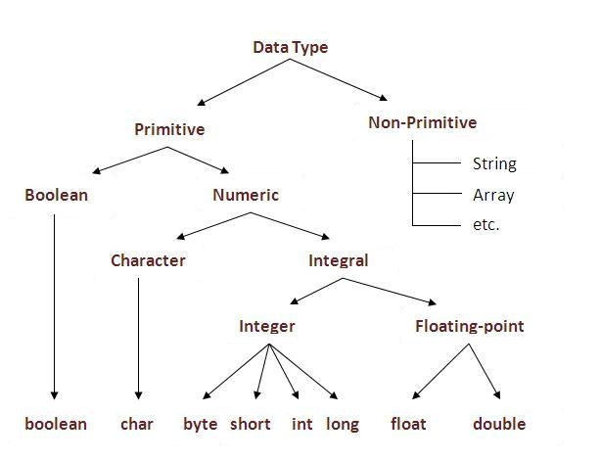

|  |  |  |
| --- | --- | --- |
| **Data Type** | **Default Value** | **Default size** |
| boolean | false | 1 bit |
| char | '\u0000' | 2 byte |
| byte | 0 | 1 byte |
| short | 0 | 2 byte |
| int | 0 | 4 byte |
| long | 0L | 8 byte |
| float | 0.0f | 4 byte |
| double | 0.0d | 8 byte |

### Why char uses 2 byte in java and what is \u0000 ?

It is because java uses Unicode system than ASCII code system. The \u0000 is the lowest range of Unicode system. To get detail explanation about Unicode visit next page.

### Java Variable Example: Add Two Numbers

1. **class** Simple{
2. **public** **static** **void** main(String[] args){
3. **int** a=10;
4. **int** b=10;
5. **int** c=a+b;
6. System.out.println(c);
7. }}

Output:

20

### Java Variable Example: Widening

1. **class** Simple{
2. **public** **static** **void** main(String[] args){
3. **int** a=10;
4. **float** f=a;
5. System.out.println(a);
6. System.out.println(f);
7. }}

Output:

10

10.0

### Java Variable Example: Narrowing (Typecasting)

1. **class** Simple{
2. **public** **static** **void** main(String[] args){
3. **float** f=10.5f;
4. //int a=f;//Compile time error
5. **int** a=(**int**)f;
6. System.out.println(f);
7. System.out.println(a);
8. }}

Output:

10.5

10

### Java Variable Example: Overflow

1. **class** Simple{
2. **public** **static** **void** main(String[] args){
3. //Overflow
4. **int** a=130;
5. **byte** b=(**byte**)a;
6. System.out.println(a);
7. System.out.println(b);
8. }}

Output:

130

-126

### Java Variable Example: Adding Lower Type

1. **class** Simple{
2. **public** **static** **void** main(String[] args){
3. **byte** a=10;
4. **byte** b=10;
5. //byte c=a+b;//Compile Time Error: because a+b=20 will be int
6. **byte** c=(**byte**)(a+b);
7. System.out.println(c);
8. }}

Output:

20